Change in recruitment deviations across five retrospective “peels” for the base model (upper panel) along with the relative change from the original recruitment deviations at each year as data are peeled away (lower panel). The base model includes the pre-recruitment survey.

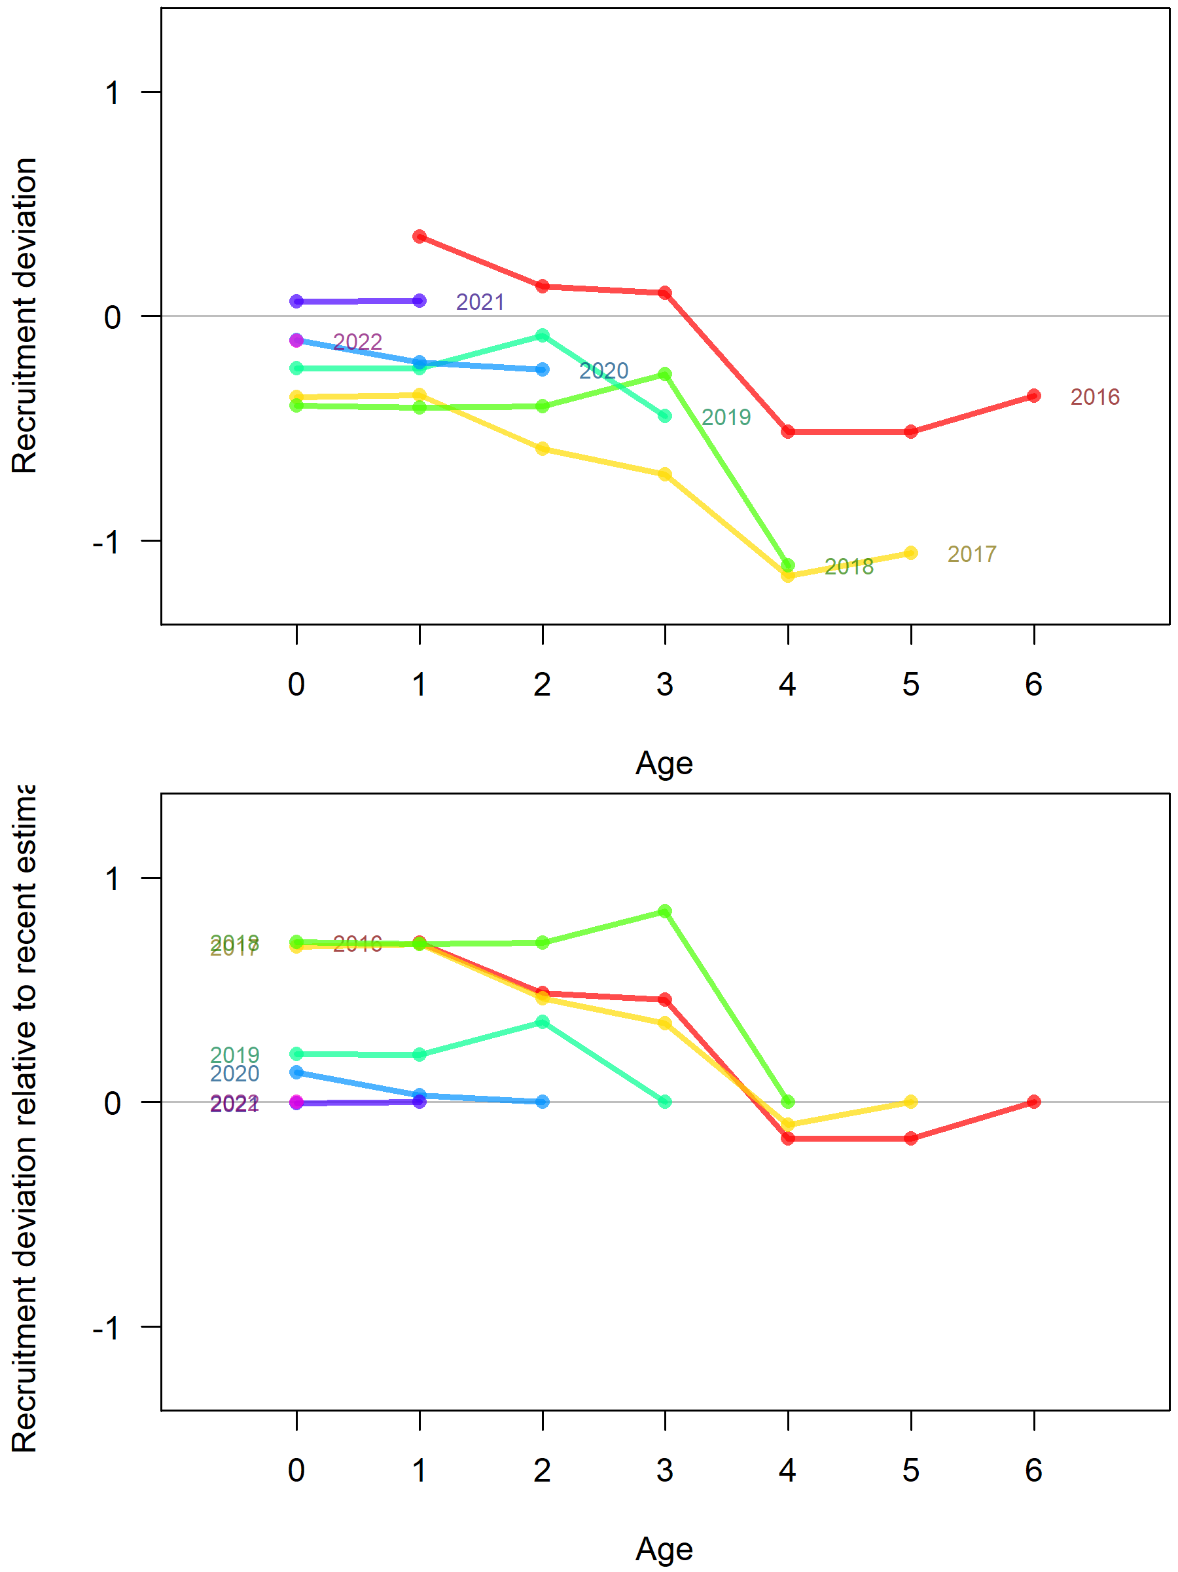

Contrasting the base model recruitment patterns for each retrospective run with similar plots for a model without the pre-recruitment survey shows that the pre-recruit survey has potential to inform recruitments. The age 0 deviations for each cohort do not converge to near 0 as years of data are removed whereas for the model without the pre-recruit survey, the age 0 deviations converge to near 0.

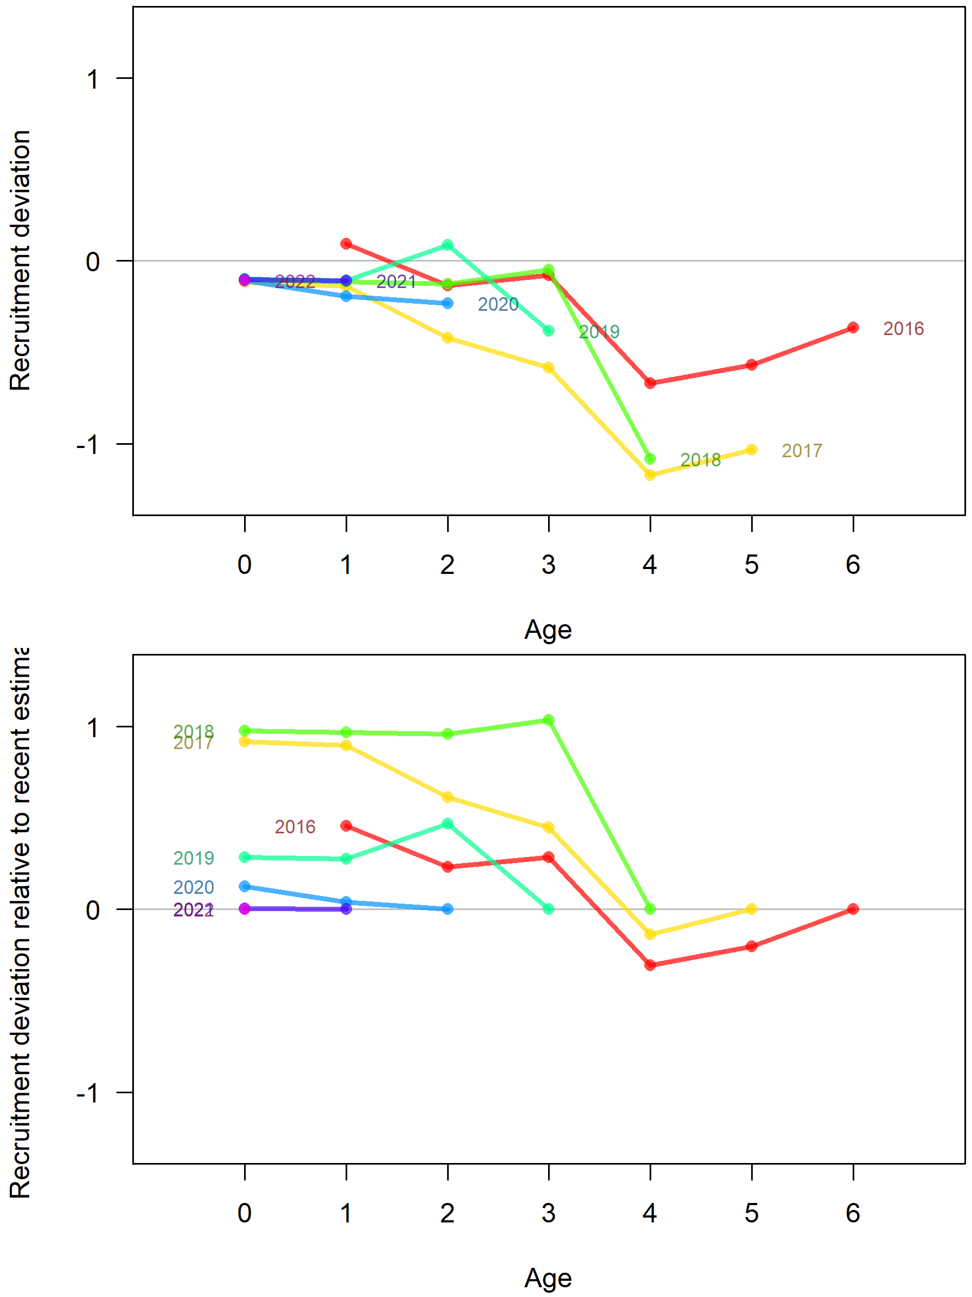

The relative change in recruitment deviations are not greatly different between the two models, which suggests that the overall pattern in recruitment deviations across ages within a cohort is not affected by the pre-recruit index. Instead, the estimate of age-0 deviations is affected, which is as expected. Recruitment deviations over time between the two models are also similar.

Recruitment deviations for the model with the pre-recruit survey:

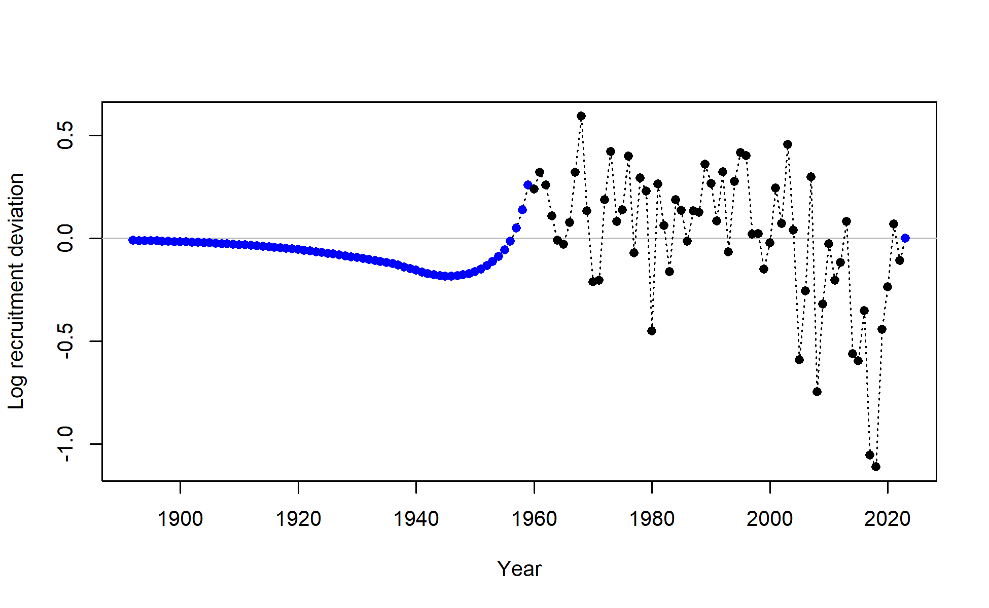

Recruitment deviations for a model without the pre-recruit survey:

